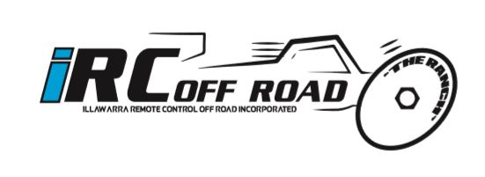
Croome Road Sporting Complex Albion Park NSW 2527
ircoffroad@hotmail.com 0413 999 395

To whom it may concern,
Illawarra Remote Control Off Road (IRC) are a local remote control car racing club located at the Croome Road sporting complex Albion Park. We currently hold club meetings, either timed practice or timed racing every fortnight with approximately 30 to 40 members and additional drivers from out of area clubs as well. In August 2017 we held the NSW state titles at our track with 100 participating drivers from not only NSW, but QLD, Canberra, WA and even New Zealand including Red Bull V8 supercar driver Shane Van Giz Gisbergen. We also hold Pro Line series, which is a 2 day race event each year that has 70 plus drivers who attend from all over the state.
We are seeking sponsors for our 2018 racing season and have the following packages to offer
Bronze level. $200 package includes weather proof signage displayed at the track on practice and race days measuring 520x900mm. Logo on the sleeve of the 2018 on the IRC shirts worn by members. Mentioned on the website.
Silver level. $400 package includes weather proof signage displayed at the track on practice and race days measuring 760x1220mm. Medium sized logo on the 2018 IRC shirt. Logo displayed on the IRC website.
Gold level. $600 package include weather proof signage displayed at the track on practice and race days measuring 760 x 1830mm in a central position. Large sized logo on the 2018 IRC shirt. Logo displayed on the IRC website and Facebook page. Company also mentioned as major sponsors on race day announcements.
Your sponsorship will help the club to upgrade the facilities such as a roof for the drivers stand as well as equipment to help maintain the track for race days such as a roller, blower vac and compressor. These items are essential for the track maintenance and continued upkeep.

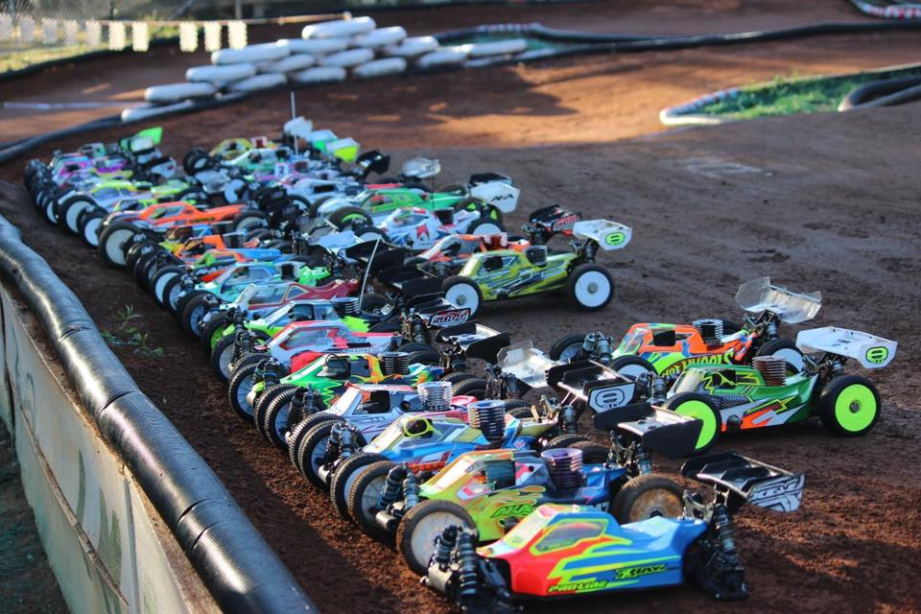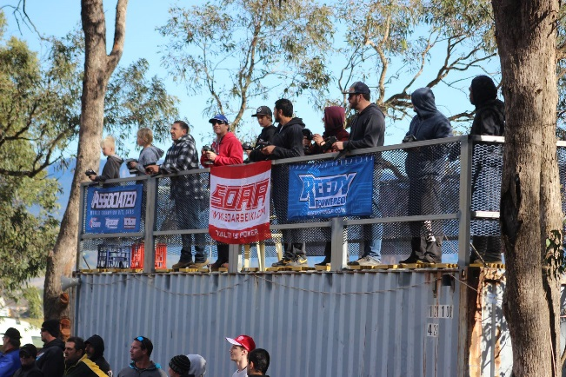
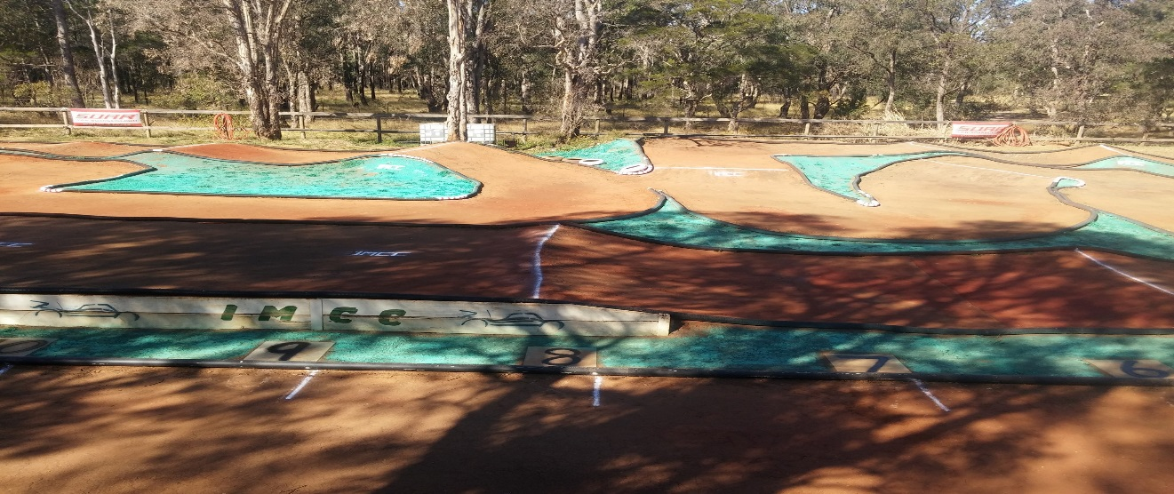
As you can see from the photos above, the layout of the track allows for signage to be placed on the fence displayed to the whole track. The Gold package will have signage in the premium position on the drivers stand.
IRC is a community club and can only continue to operate successfully with the ongoing support of local businesses and community members. Inspections of our club and track are always welcome.
If you have any questions, please contact our treasurer Karen Ellis on 0413 999 395. Payments can be made via bank transfer, cheque or cash.

Kind regards

IRC Offroad
Karen Ellis

